Assignment-14-May-2022

1. What is DNS? Explain

: The Domain Name System is the hierarchical and decentralized naming system used to identify computers reachable through the Internet or other Internet Protocol networks.

The resource records contained in the DNS associate domain names with other forms of information.

USE: The Domain Name System (DNS) turns domain names into IP addresses, which browsers use to load internet pages.

Every device connected to the internet has its own IP address, which is used by other devices to locate the device.

WORK:

Step 1: Requesting Website Information.

Step 2: Contact the Recursive DNS Servers.

Step 3: Query the Authoritative DNS Servers.

Step 4: Access the DNS Record.

Step 5: Final DNS Step.

Authoritative DNS Server.

Recursive Nameserver.

2. What is Route 53?

: Amazon Route 53 is a highly available and scalable cloud Domain Name System (DNS) web service.

It is designed to give developers and businesses an extremely reliable and cost-effective way to route end users to Internet applications by translating names like www.example.com into the numeric IP addresses

The name for our service (Route 53) comes from the fact that DNS servers respond to queries on port 53 and provide answers that route end users to your applications on the Internet.

3. What is hosted zone?

: A hosted zone is an Amazon Route 53 concept. A hosted zone is analogous to a traditional DNS zone file; it represents a collection of records that can be managed together, belonging to a single parent domain name.

Each Amazon Route 53 account is limited to a maximum of 500 hosted zones and 10,000 resource record sets per hosted zone.

OR

A hosted zone is a container for records, and records contain information about how you want to route traffic for a specific domain, such as example.com, and its subdomains (acme.example.com, zenith.example.com). A hosted zone and the corresponding domain have the same name.

4. What is sub-domain routing?

: Subdomain routing is like route prefixing yet with scope only within the subdomain.

Two primary uses of subdomain routing. Present different section of the application to different subdomain. Set part of the subdomain as parameter.

Route 53 looks in the hosted zone for the domain (example.com) and finds the NS record for the subdomain (acme.example.com). Route 53 gets the name servers from the acme.example.com NS record in the hosted zone for the domain, example.com, and returns those name servers to the DNS resolver.

5. What are the features of route 53?

: Route 53 is an “authoritative DNS” system.

* An authoritative DNS system provides an update mechanism that developers use to manage their public DNS names.
* It then answers DNS queries, translating domain names into IP address so computers can communicate with each other.

OR

* Amazon Route 53 is a highly available and scalable Domain Name System (DNS) web service.
* You can use Route 53 to perform three main functions in any combination:
  1. Domain registration,
  2. DNS routing Police
  3. DNS hosting
  4. Traffic management
  5. Health checking.

6. Do hands on, create domain name, create hosted zone in aws for ec2 instance and check whether it’s working?

: **To create domain name**

Search for [ freenom]

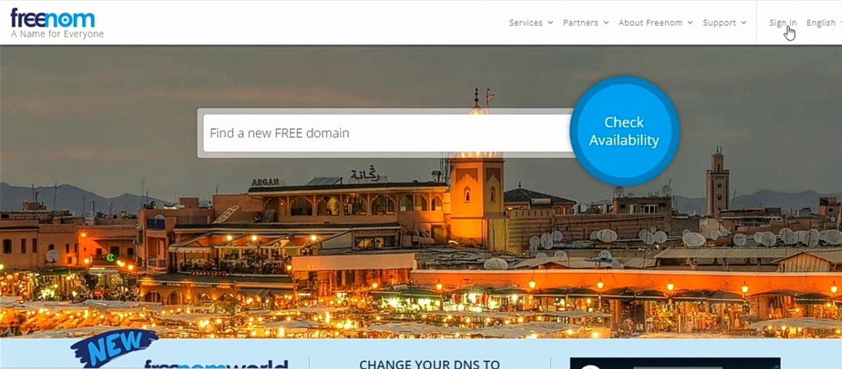

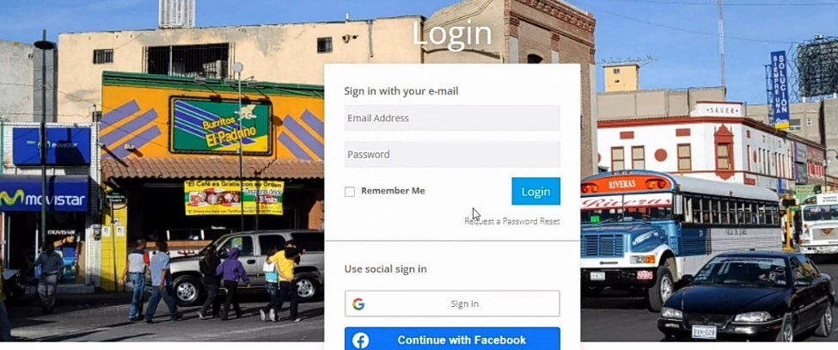Sign in to freenom using Gmail

Go for services

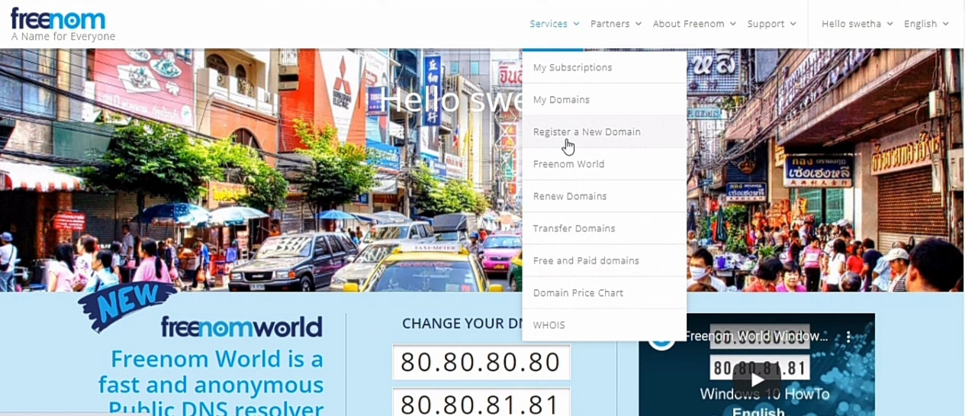

Register a new domain

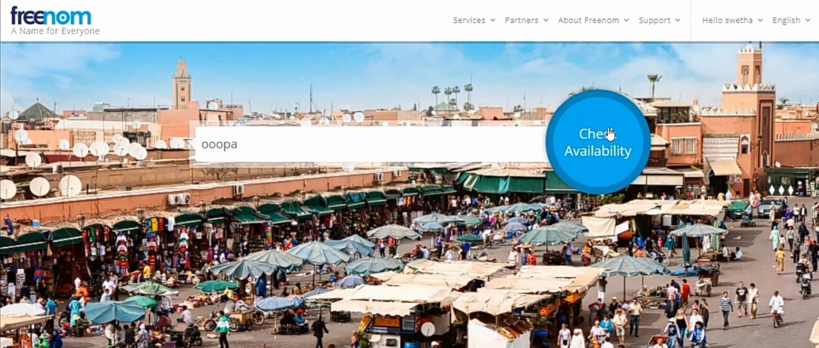

Search for [ooopa]

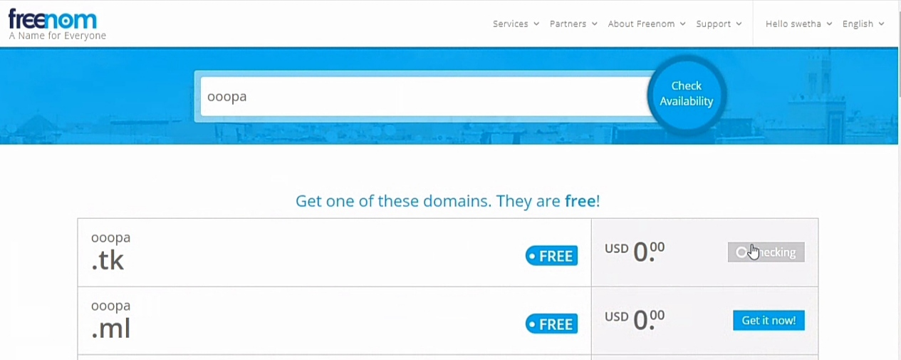

checkout

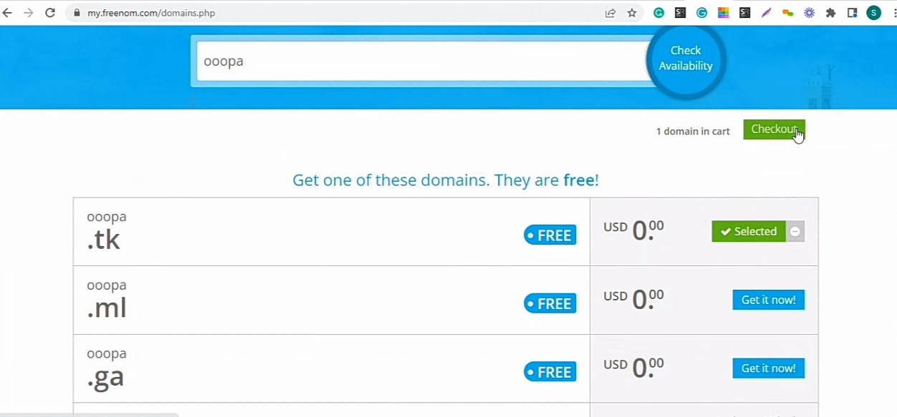

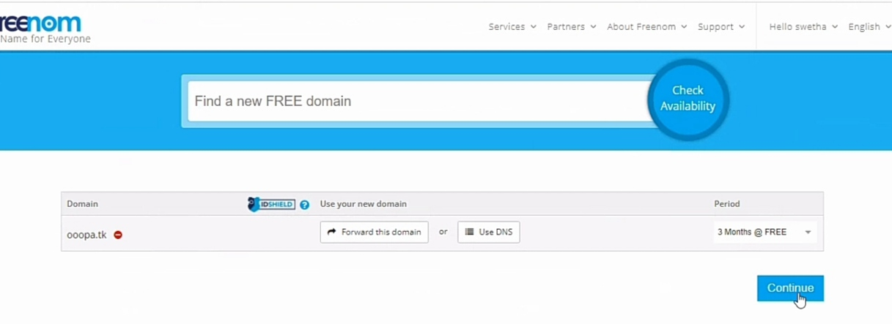

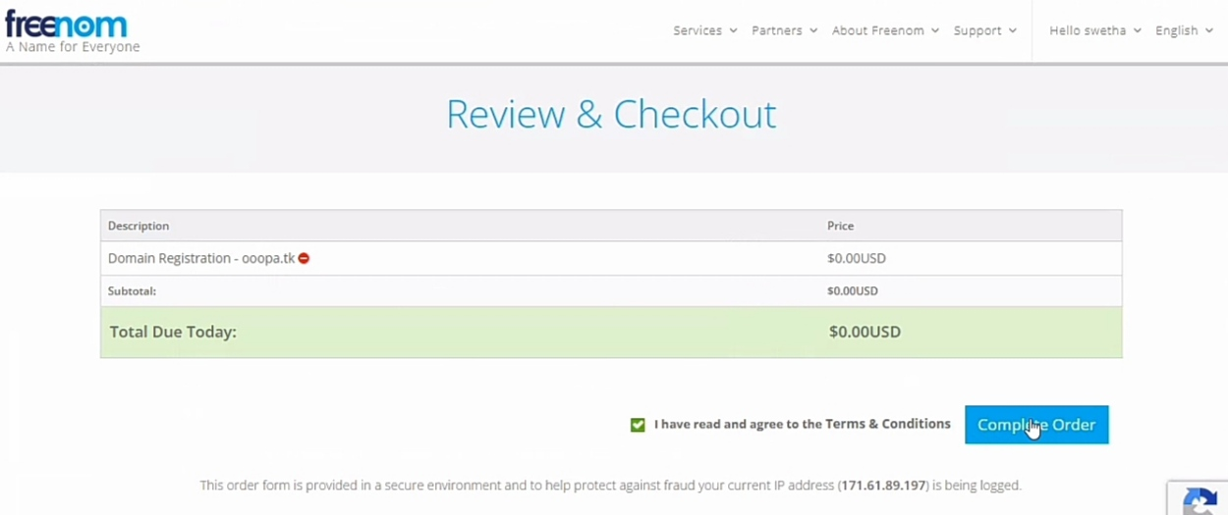

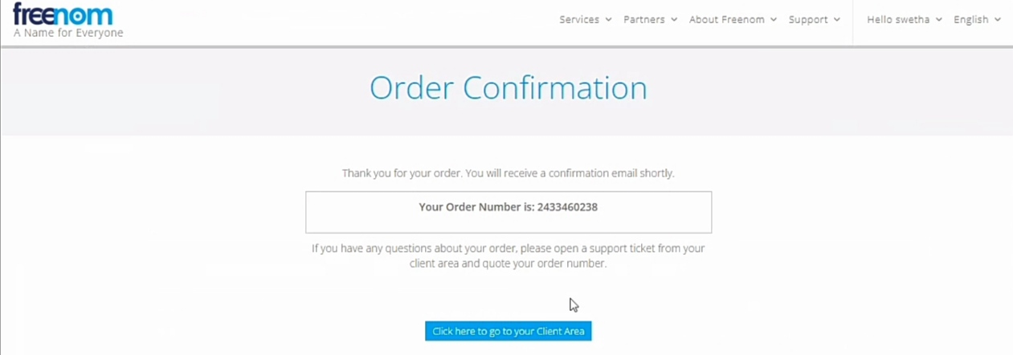

Go to client area select my domain

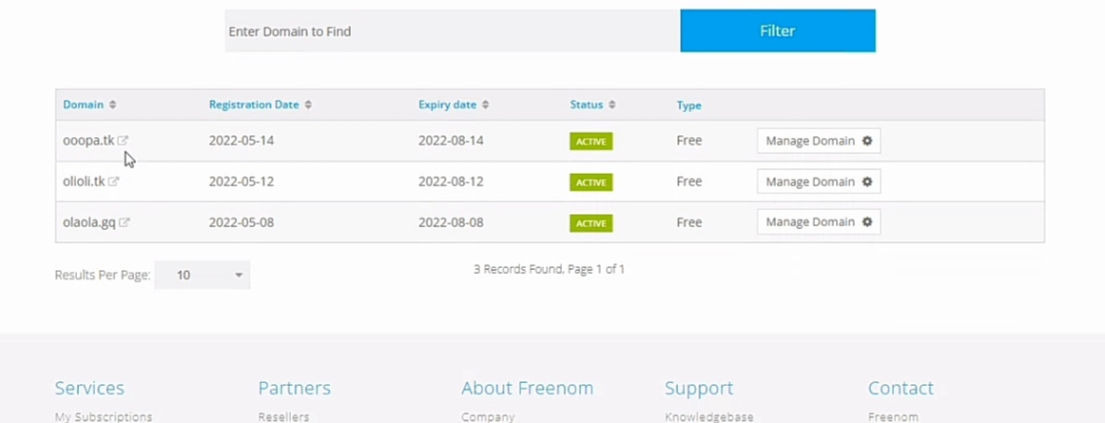

**To create a public hosted zone using the Route 53 console**

1. Sign in to the AWS Management Console and open the Route 53 console at <https://console.aws.amazon.com/route53/>.
2. If you're new to Route 53, choose **Get started** under **DNS management**.

If you're already using Route 53, choose **Hosted zones** in the navigation pane.

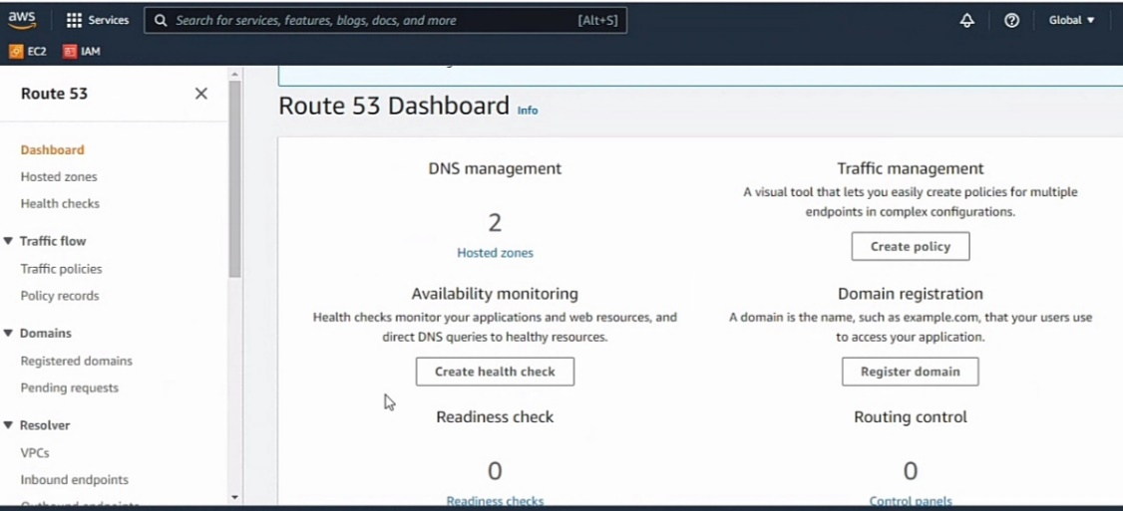

1. Choose **Create hosted zone**.

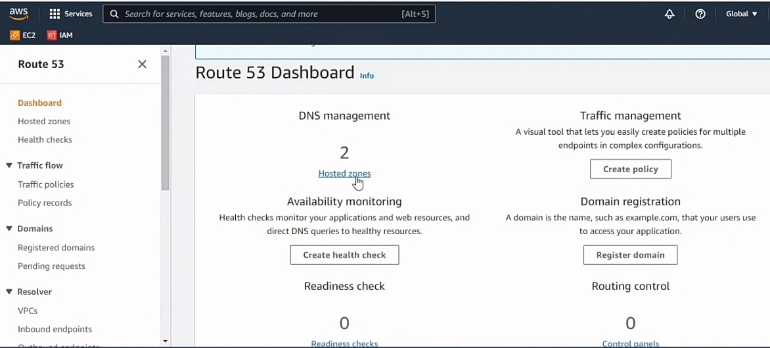

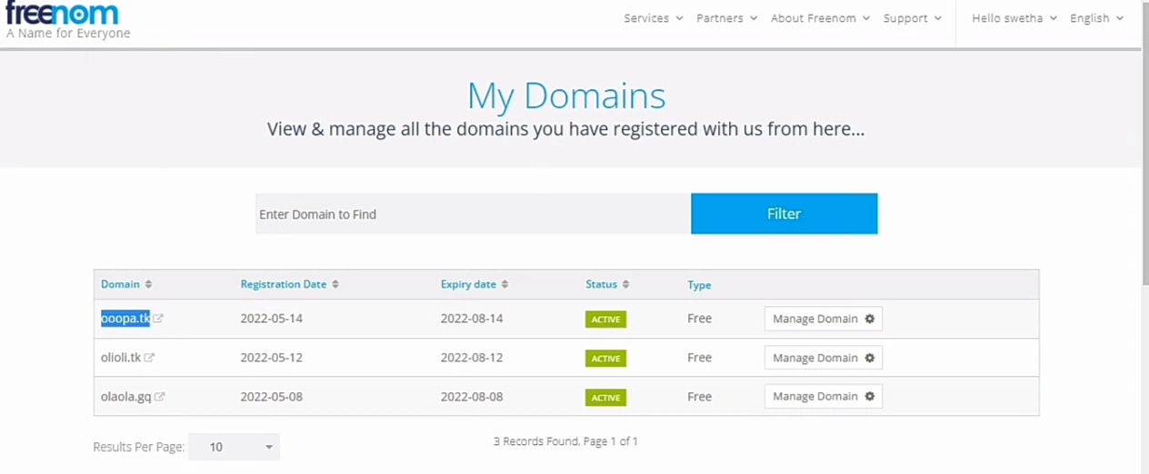

1. In the **Create Hosted Zone** pane, enter the name of the domain that you want to route traffic for. You can also optionally enter a comment.

For information about how to specify characters other than a-z, 0-9, and - (hyphen) and how to specify internationalized domain names, see [DNS domain name format](https://docs.aws.amazon.com/Route53/latest/DeveloperGuide/DomainNameFormat.html).

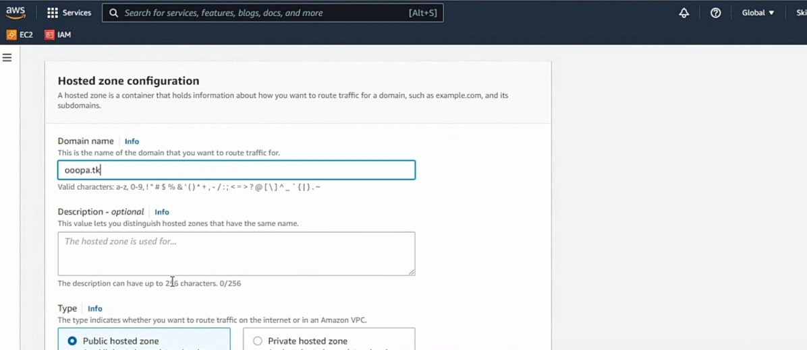

1. For **Type**, accept the default value of **Public Hosted Zone**.

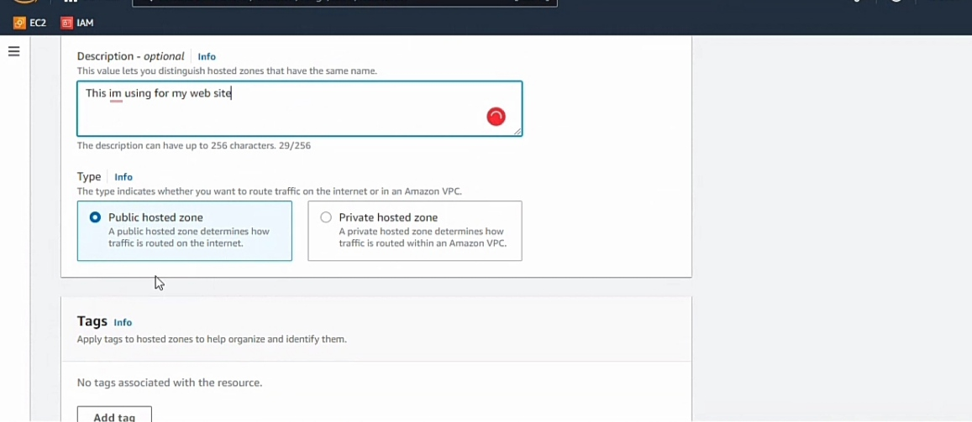

1. Choose **Create**.

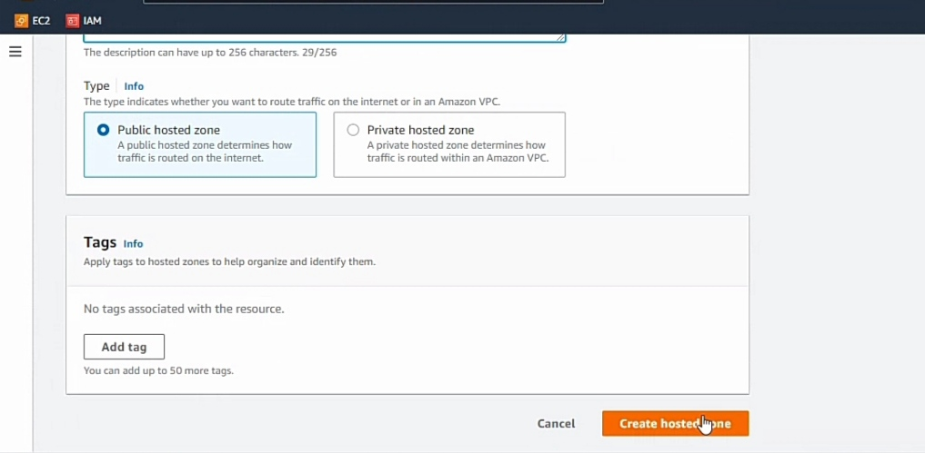

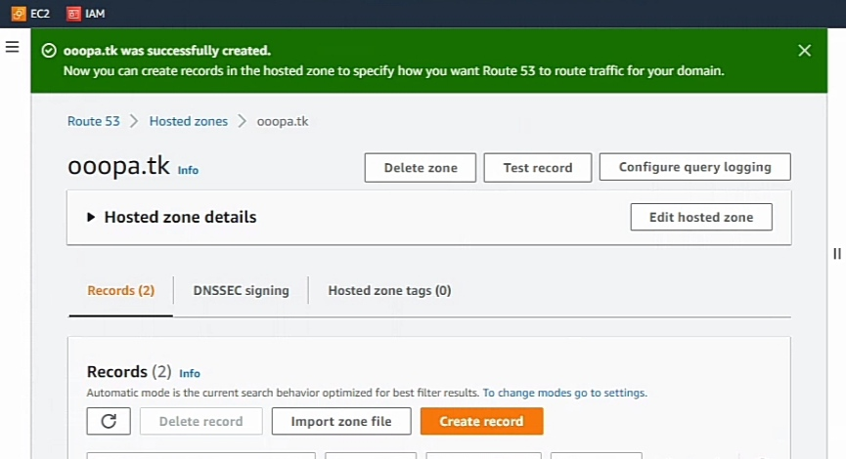

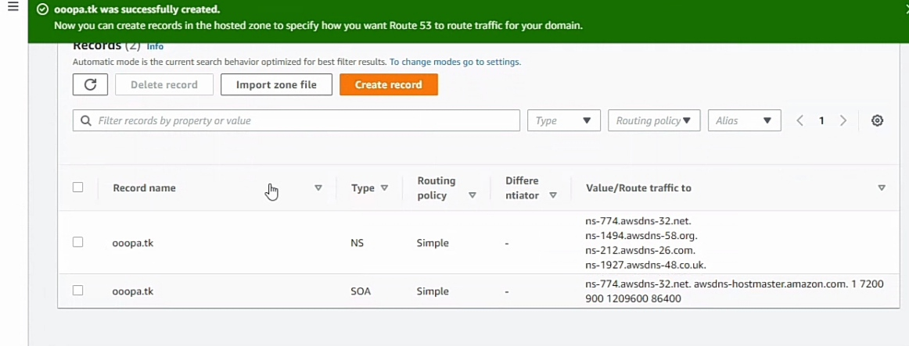

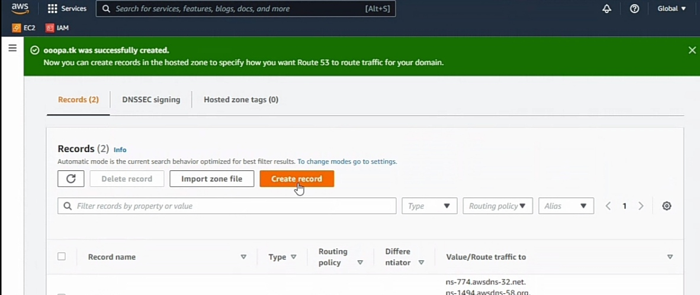

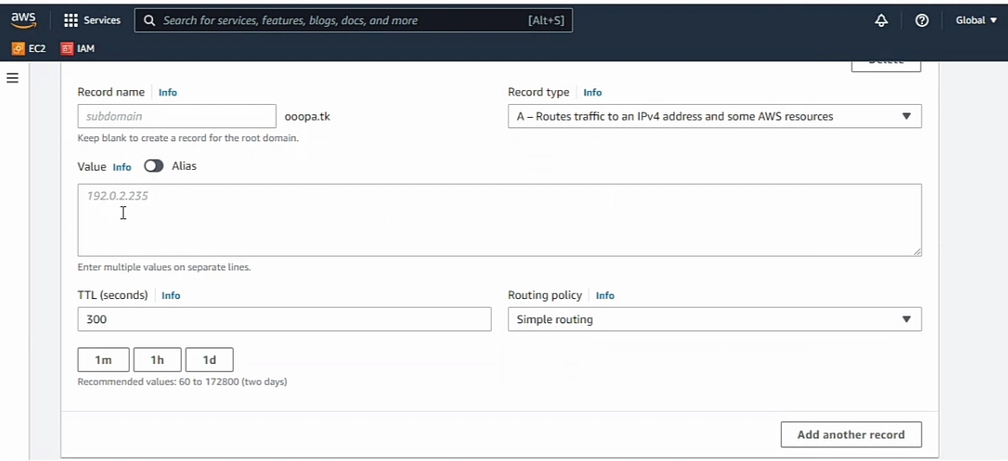

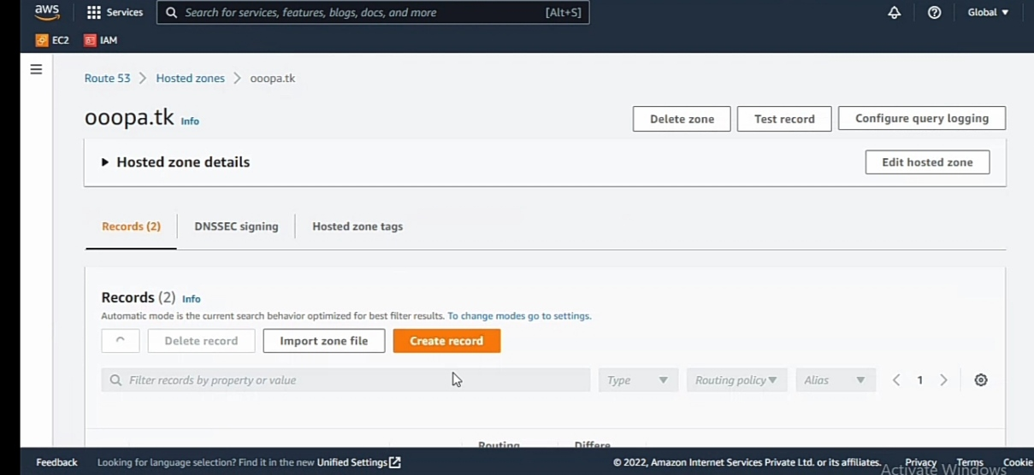

1. Create records that specify how you want to route traffic for the domain and subdomains. For more information, see [Working with records](https://docs.aws.amazon.com/Route53/latest/DeveloperGuide/rrsets-working-with.html).

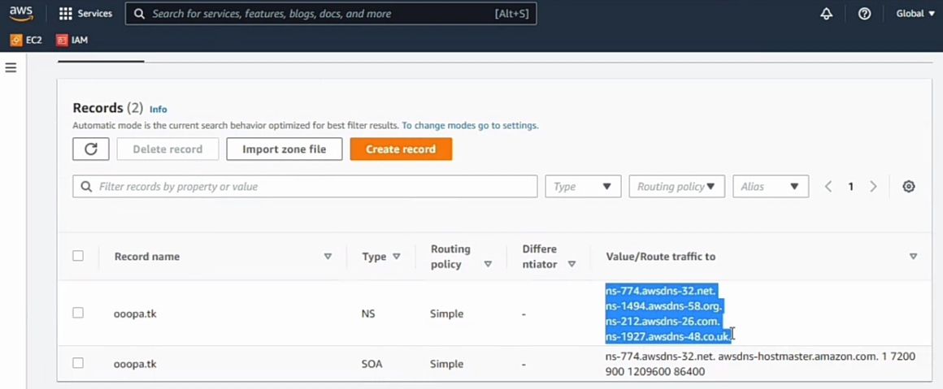

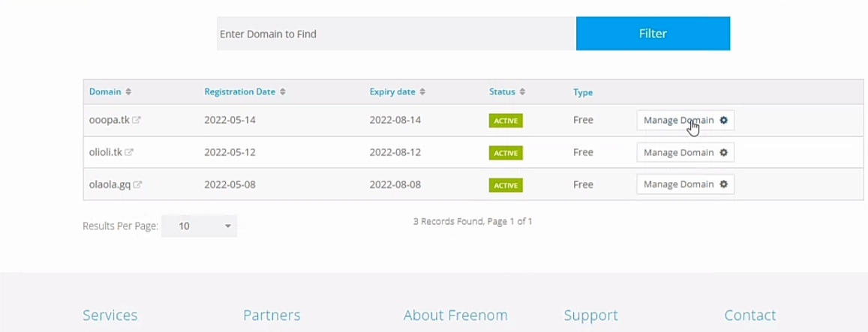

1. To use records in the new hosted zone to route traffic for your domain, see the applicable topic:
   * If you're making Route 53 the DNS service for a domain that is registered with another domain registrar, see [Making Amazon Route 53 the DNS service for an existing domain](https://docs.aws.amazon.com/Route53/latest/DeveloperGuide/MigratingDNS.html).
   * If the domain is registered with Route 53, see [Adding or changing name servers and glue records for a domain](https://docs.aws.amazon.com/Route53/latest/DeveloperGuide/domain-name-servers-glue-records.html).

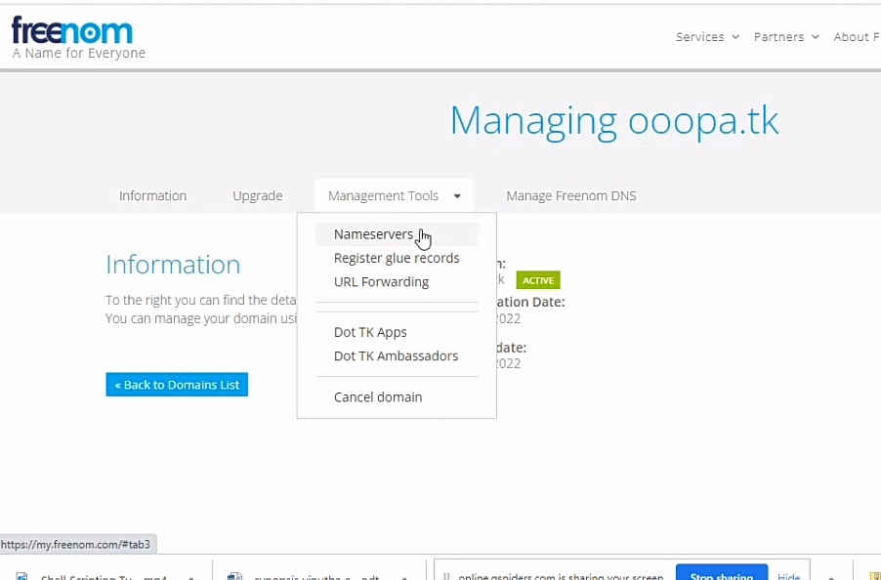

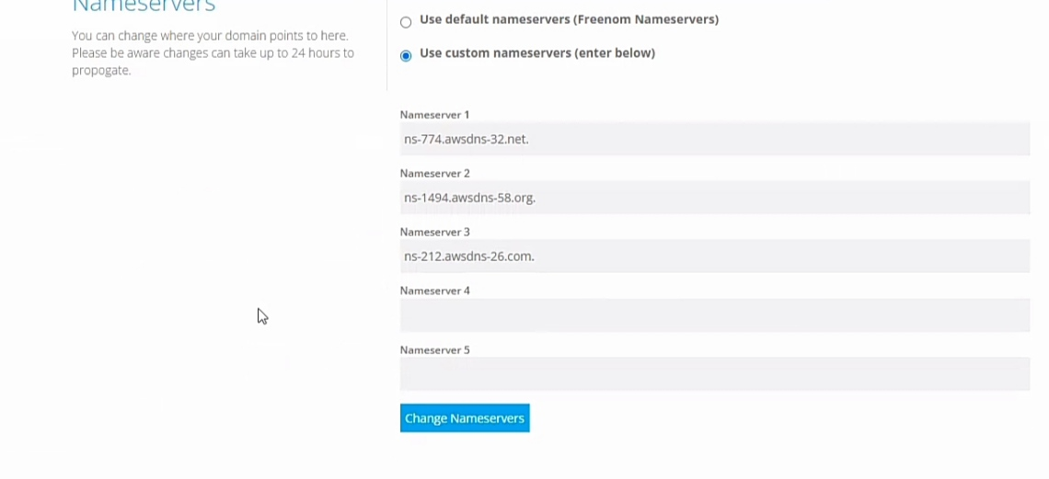

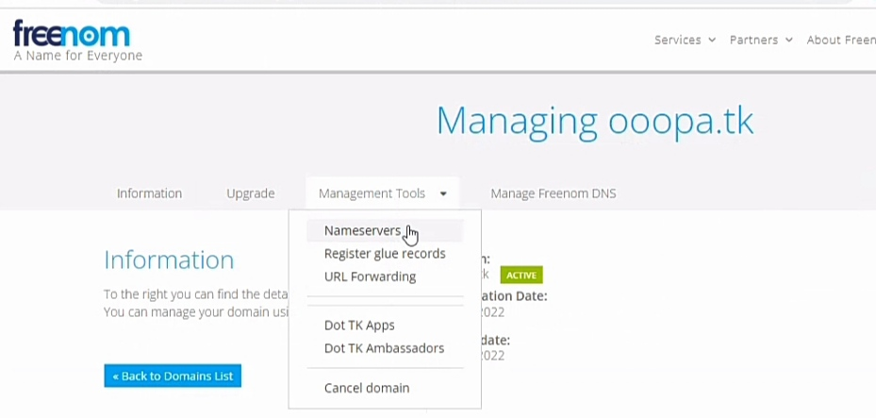

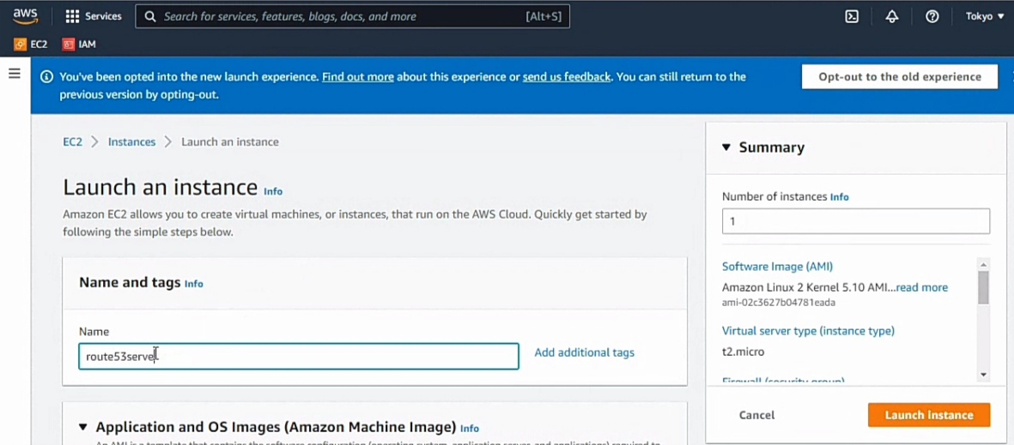

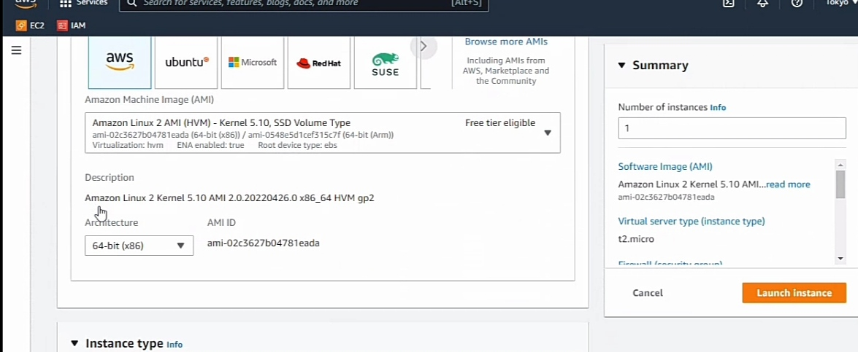

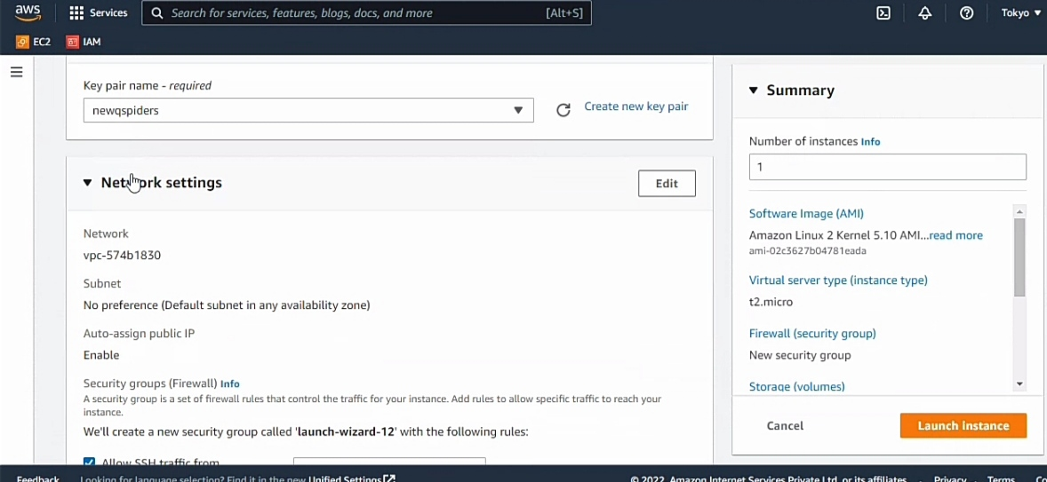

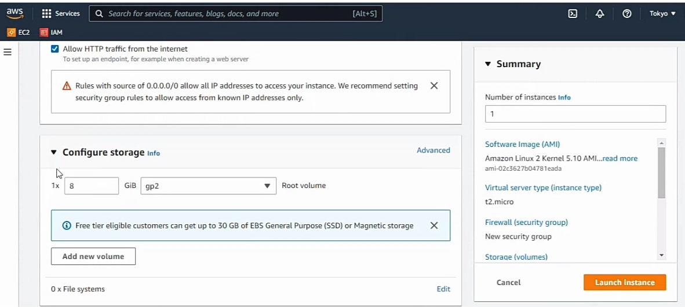

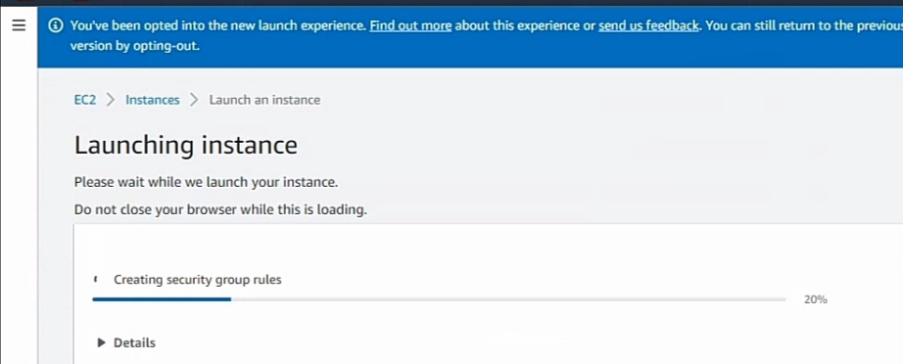

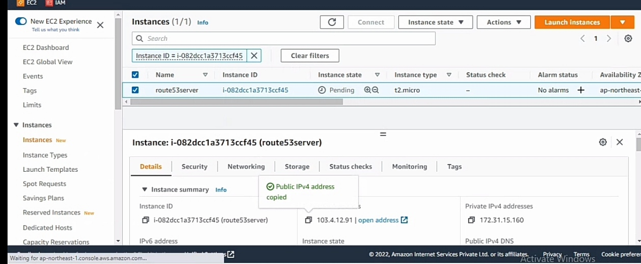

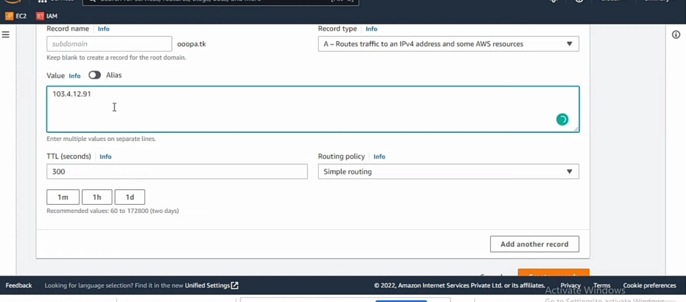

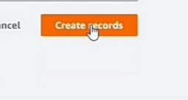

7. What is single point of?

: A single point of failure is a part of a system that, if it fails, will stop the entire system from working.

SPOFs are undesirable in any system with a goal of high availability or reliability, be it a business practice, software application, or other industrial system.

OR

A SPOF or single point of failure is any non-redundant part of a system that, if dysfunctional, would cause the entire system to fail.

A single point of failure is antithetical to the goal of high availability in a computing system or network, a software application, a business practice, or any other industrial system.

8. What is the drawback of vertical scaling?

:

* Limited Scaling.
* The risk for downtime is much higher than horizontal scaling.
* Greater risk of outages and hardware failures.
* Finite scope of upgradeability in the future.
* Severe vendor lock-in.
* The cost of implementing is expensive.

9. What is Auto-Scaling?

: AWS Auto Scaling monitors your applications and automatically adjusts capacity to maintain steady, predictable performance at the lowest possible cost.

Using AWS Auto Scaling, it's easy to setup application scaling for multiple resources across multiple services in minutes.

OR

Autoscaling is a cloud computing feature that enables organizations to scale cloud services such as server capacities or virtual machines up or down automatically, based on defined situations such as traffic ir utilization levels.

10. What is Load Balancing?

: Load balancing is the process of distributing network traffic across multiple servers. This ensures no single server bears too much demand.

By spreading the work evenly, load balancing improves application responsiveness.

It also increases availability of applications and websites for users.

11. What is High Availability and Fault tolerance?

: High availability (HA)

* High availability (HA) is a component of a technology system that eliminates single points of failure to ensure continuous operations or uptime for an extended period. High Availability solutions ensure your systems, databases, and applications operate when and as needed.
* High availability is a quality of computing infrastructure that allows it to continue functioning, even when some of its components fail. This is important for mission-critical systems that cannot tolerate interruption in service, and any downtime can cause damage or result in financial loss.
* High availability software solutions offer data protection for all the legacy file data that businesses want to move to Amazon Web Services (AWS), as well as reliable performance with minimal downtime and costs.

Fault tolerance (FT)

* Fault tolerance is a process that enables an operating system to respond to a failure in hardware or software. This fault-tolerance definition refers to the system's ability to continue operating despite failures or malfunctions.
* Cloud fault tolerance simply means your infrastructure is capable of supporting uninterrupted functionality of your applications despite failures of components. In a cloud computing setting that may be due to autoscaling across geographic zones or in the same data centres
* Fault tolerance is the ability of a workload to remain operational with zero downtime or data loss in the event of a disruption. In a fault-tolerant environment, instances of the same workload are typically hosted on two or more independent sets of servers.

12. What are the different types of Load Balancers?

: Different Types of Load Balancing Algorithms in Cloud Computing:

* Static Algorithm.
* Dynamic Algorithm.
* Round Robin Algorithm.
* Weighted Round Robin Load Balancing Algorithm.
* Opportunistic Load Balancing Algorithm.
* Minimum To Minimum Load Balancing Algorithm.